MUNICIPALITY OF FIVE RIVERS
REQUEST FOR PROPOSAL-FR-2025-01
LAND DISPOSAL- PID 25140823 – NORTH LOT
The Municipality of Five Rivers (“Municipality”) invites interested parties to submit a Request for Proposal (“RFP” or “Proposal”) regarding the disposal of lands currently owned by the Municipality located at the conjunction of Main Street and Enterprise Street on PID 25140823 with a size of approximately 8.5 acres (the “North Lot”). The submission should include an offer to purchase the said land from the Municipality. Request for Proposal packages may be picked up at the Five Rivers Municipal Office, 82 Main Street, Rexton, NB E4W 5N4.
Sealed submissions shall be endorsed:
  - REQUEST FOR PROPOSAL FR-2025-01
PID 25140823 – NORTH LOT - LAND DISPOSAL
and shall be addressed to:
Five Rivers
82 Main Street
Rexton, New Brunswick, E4W 5N4
ATTENTION: EMILY PRATT
Submissions shall be delivered to this address by 3:00 PM, local time on November 30, 2025.
This Request for Proposal is not an offer to sell to the highest or any bidder.
The Municipality does not commit to making an award or commit to the sale of its land. However, the Municipality reserves the right to (a) reject all submissions not deemed to be in the best interest of Five Rivers and (b) dispose of its lands by other means.

INTRODUCTION
The Municipality invites interested parties to submit a Request for Proposal regarding the disposal of lands currently owned by the Municipality located at the conjunction of Main Street and Enterprise Street having PID 25140823 for an area of approximately 8.5 acres (North Lot).
TITLE: Municipality of Five Rivers REQUEST FOR PROPOSAL FR-2025-01
PID 25140823 – NORTH LOT - LAND DISPOSAL
The submissions will be received at the Municipal Office, 82 Main Street, Rexton, NB E4W 5N4 until 3:00 P.M. local time on November 30, 2025. Proposals shall be binding for 90 days unless otherwise specified. All proposals submitted shall be irrevocable for ninety (90) calendar days following the opening date unless the Proponent(s), upon request of the CAO of Fiver Rivers, agrees to an extension.
The Municipality’s Council has reviewed this parcel of land and deemed it surplus property. It is currently zoned COMMERCIAL LAND. Other uses will be considered if deemed to be in the best interest of the residents of the Municipality.
At present, the South Lot and North Lot share the same PID. The municipality plans to subdivide the property into these two lots, pending responses to the RFPs.

INSTRUCTIONS
1. INSTRUCTION AND FORMS
The Request for Proposal document may be obtained in person, by email or fax from the Municipal Office, which is located at 82 Main Street, Rexton, NB E4W 5N4. However, you shall contact us for a copy.
- All proposals are to be submitted in accordance with the Request for Proposal document.
- All proposals are to be submitted in a sealed and plainly marked envelope.
- Additional information or clarification regarding the instructions or information contained herein may be obtained from the CAO or a designated representative.
- Any Proponent that has a question or issue with this Request for Proposal shall notify the Municipality in writing five (5) days prior to the scheduled closing date for this Request for Proposal. If the Proponent’s question or issue demands a response from the Municipality, the Municipality will share its response with all Proponents in writing, by addendum duly issued.
- The Municipality shall assume no responsibility for oral instructions or suggestions.
2. ELIGIBILITY
Proponents are not eligible to submit a proposal if, in the opinion of the Municipality, it gives rise to a conflict of interest in connection with this project. Proponents are to submit with their proposal information, documents that may constitute a conflict-of-interest violation for review by the Municipality. The Municipality’s decision on this matter shall be final.
3. RESERVATION
- The Municipality reserves the right to reject or accept proposals when in their reasoned judgment the public interest is best served.
- The Municipality may waive formalities or technicalities in proposals as the Municipality may require.
- The Municipality may waive minor differences in the proposal if they do not violate the intent of the proposal.
4. DISPUTES
In cases of dispute as to whether an item or service quoted or delivered meets the proposal requirements, the decision of the Municipality shall be final and binding on all parties.
5. PROPONENTS EXPENSES
Proponents are solely responsible for all expenses incurred in preparing, delivering, or presenting the proposal or subsequent negotiations with the Municipality, including any legal fees, transfer taxes, or other associated costs.
6. EXCEPTIONS
The submission of a proposal shall be considered an agreement to all the terms and conditions provided herein and in the various proposal documents unless specifically noted otherwise in the proposal.
7. CURRENCY AND TAXES
Prices are to be quoted in Canadian dollars, inclusive of duty, where applicable and exclusive of HST.
8. COMPLIANCE WITH LAWS
The Proponent and/or its contractor shall give all notices and obtain all licenses and permits required to perform the work. The same shall comply with all the applicable laws and by-laws to the contract work or performance.
9. RESERVE PRICE
To ensure that Council meets the expectations of the taxpayers of Five Rivers, a formal appraisal will be completed by a qualified local real estate agent, and a minimum bid price will be established based on the estimated market value of the land.

REQUIREMENTS
1. INTRODUCTION
- The Municipality invites Proponents to submit proposals that can be expected to complement or enhance the surrounding neighbourhood.
- “Request for Proposal” will be referred to as RFP.
- “Proponent” means those who respond to this RFP.
- “Preferred Proponent” means the Proponent who has been recommended to Council to enter into a Purchase & Sale Agreement for the property.
- “Company” is the selected Proponent after it has signed the Agreement.
- “Agreement” in this RFP refers to a Purchase and Sale Agreement to take ownership of the land, which may also include a Development Agreement.
2. DESCRIPTION OF PARCEL (the “LAND”)
- The North Lot is a parcel of land on PID 25140823.
- The North Lot is in the “Industrial Area” of Five Rivers at the conjunction of Main Street and Enterprise Street.
- The North Lot is approximately 8.5 acres in size.
- The North Lot is zoned as COMMERCIAL LAND.
- The North Lot may be connected to the sewer system of Five Rivers and the water system of Beaurivage.
- Any merchantable wood on the North Lot shall be the property of the Company.
- The Municipality is unaware of any contamination/hazard on the North Lot.
- The Municipality offers the North Lot for sale on an as-is basis.
3. DESIGN
The design, layout and construction of this development shall conform to all applicable Municipal standards.
4. APPROVALS
The final decision for approval of this or any development shall be made by Council.
5. LAND USE BY-LAWS
The parcel of land is zoned as COMMERCIAL LAND and shall comply to the current conditions under the Rexton Rural Plan for the Municipality of Five Rivers. If the proposed use falls outside of the current zoning, it shall be up to the successful Proponent to re-zone the parcel to comply with the intended use.
6. INDEMNITY
If the contract is awarded, the successful Proponent shall be required to indemnify and hold the Municipality harmless from and against all liability and expenses, including solicitor’s fees, howsoever arising or incurred, alleging damage to property or injury to, or death of, any persons arising out of or attributing to the Proponent’s performance of the contract awarded.
Any property or work to be provided by the Proponent under this contract shall remain at the Proponent’s risk until written acceptance by the Municipality; and the Company shall replace, at the Proponent’s expense, all property or work damaged or destroyed by any cause whatsoever.
7. SUBMISSION OF PROPOSAL DOCUMENTS
The submission of a proposal shall be considered as a representation that the Proponent has carefully investigated all components of the purchase and development of the site, as outlined in the RFP and that the Proponent is fully informed regarding the conditions to be encountered, the quality and quantity of work to be performed, the materials to be furnished, and other requirements of this RFP. In addition, the Proponent shall be familiar with all Federal and Provincial laws, and all codes and ordinances of the Municipality, which in any way affect the development of the site and other works.
8. CONTENT OF PROPOSAL DOCUMENTS
To respond to this RFP, each Proponent shall complete and submit the following required information.
- A description of the planned use for the land, including all structures to be constructed.
- A drawing or image of the proposed development.
- A project timeline or schedule that lists tasks/milestones by start and finish date.
- The potential value of the project.
- The proposed purchase price.
- Any other information the Proponent would deem relevant.
The potential value (d) and purchase price (e) shall be submitted by using the form in Appendix B.
9. BID INSTRUCTIONS
In responding to this RFP, each Proponent shall complete and submit all the required information and either the Proponent or an authorized Company official shall sign and seal it with the corporate seal.
10. AWARD
The Municipality reserves the right to modify the terms of the Request for Proposal at any time at its sole discretion. The Municipality will post an Addendum to the RFP if any changes occur.
This Request for Proposal should not be construed as a contract between the Municipality and the Proponent. The Municipality is not bound to accept the lowest or any proposal of those submitted.
The Municipality shall not be obligated in any manner to any Proponent whatsoever until a written contract has been duly executed relating to an approved proposal by Council.
Neither acceptance of a proposal nor execution of a contract shall constitute approval of any activity or development contemplated in any proposal that requires any approval, permit, or license pursuant to any federal, provincial, regional district or municipal statute, regulation, or the Rexton Rural Plan.
11. CONTRACT AGREEMENT
The Preferred Proponent shall be eligible to enter into a Purchase & Sale Agreement for the Land with the Municipality. The Agreement shall close no later than sixty (60) days after the notice of award. In most cases, the Agreement will include the following:
- If the municipality contributes funding for public infrastructure, the value of that funding will be deducted from any municipal grants or development incentives that the Company is eligible or due to receive for the project.
- A buy-back clause that permits the Municipality to reacquire the land if the Developer does not execute the Development Plan within a given period (typically, 4 to 7 years).
12. DISCLAIMER
The Municipality reserves the right to reject all proposals, for any reason, including failure to meet the Reserve Price. In addition, the Municipality may cancel this RFP, reject all the proposals, and issue a new Request for Proposal or other means.
All submissions become the property of the Municipality.
The Municipality shall not be liable for any costs incurred by a Proponent in responding to this RFP, regardless of whether the Municipality awards the Contract through this process, decides to not go forward with the project, cancels this RFP for any reason, or contracts the Project through some other process or by issuing another RFP.
13. EVALUATION AND RECOMMENDATION
All accepted proposals will be evaluated and scored by Council using the Evaluation Criteria in this RFP, which address both the technical merit and the financial merit of the proposal. The Proponents with the highest scoring proposal will be invited to enter into a Purchase & Sale Agreement.
The Evaluation Criteria for this RFP will be, and have relative weights, as follows:
- Purchase Price (25 points). One-time, up-front purchase price for property.
- Future Value (25 points). Projected long-term value to municipality, based on 20-year tax revenues minus all municipal incentives.
- Strategic Alignment (25 Points). Alignment with Strategic Plan of Five Rivers with respect to land use, economic development, housing, beautification, and so on.
- Quality of Plan (25 Points). Broadly speaking, this is based on development plan quality and detail, project plan and timeline, builder expertise and references, and builder financial strength.
14. FORMALITY CLAUSE
For the Municipality to consider any proposal submission as a legally binding offer, the Proponent shall communicate this formality to the Municipality in the form of an offer, prefaced by a cover letter that contains the original signature of the individual or representative of the firm who is authorized to act on behalf of the organization.

APPENDIX A
Figure 1: Overall Site Map
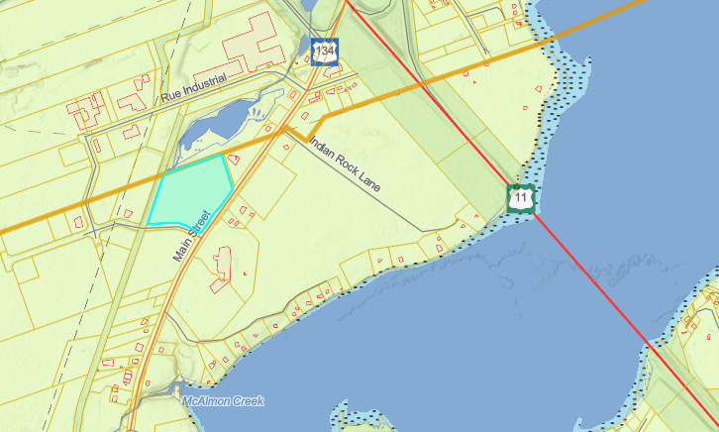
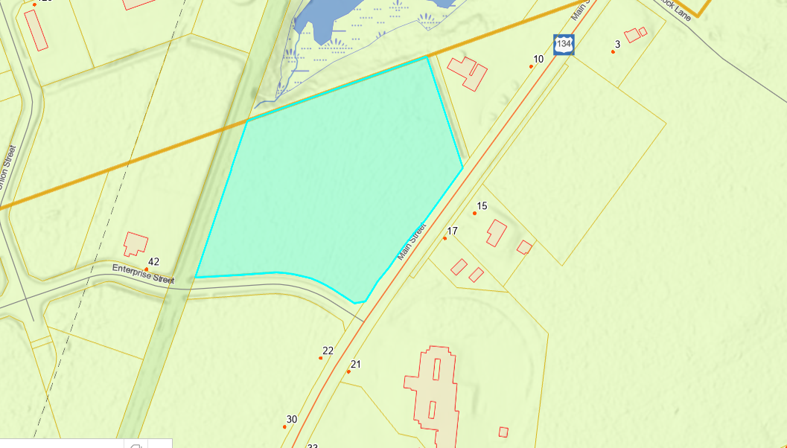
Figure 2: Neighborhood Map

APPENDIX B
RFP FR-2025-01 | PID 25140823 – NORTH LOT
BID SUBMISSION
Name
[First Name Last Name]
Address
[Street, Province, Province]
Phone
[XXX-XXX-XXXX]
Email
[xxx@yyy.zz]
Regarding Request for Proposal FR-2025-01, for the purchase of land with PID 21540823 – North Lot,
I/we are proposing the following purchase price, $ (plus applicable fees and taxes).
In Writing,
 | Dollars |  | Cents
I/We the undersigned, herewith propose to purchase PID 25140823 – North Lot, in accordance with the specifications issued by the Municipality of Five Rivers.
Name of Purchaser |  | Authorized Signature & Date

