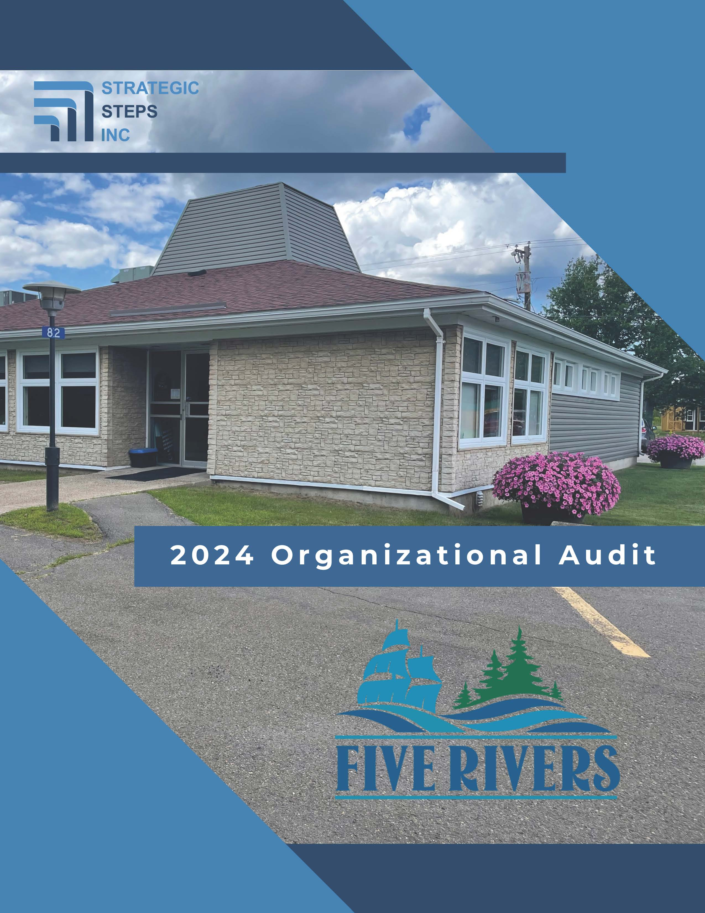

Executive Summary
Through the winter and spring of 2024, Strategic Steps Inc. was asked by the council of Five Rivers, NB to provide insight into the municipality’s service delivery; particularly whether the organizational structure, governance and administrative policies, bylaws, and human resource processes are sufficient to ensure efficient and effective delivery of municipal services.
This is an audit rather than a full organizational review. Essentially this means that the process looks for that proverbial smoke to indicate whether and where there might be fire. In cases where ‘fire’ was identified, the audit would recommend a deeper review of the particular areas where more attention would provide value.
Overall, Five Rivers appears to be providing the services that are required and expected in a well-functioning municipality of its size and complexity. As with any audit of this sort, there are areas on which we recommend spending more time or putting some consideration into changes.
Five Rivers’ vision is: A welcoming, safe community with a hometown feel, an appreciation for nature, and respect for our environment. We took this as the ultimate expression of success for the municipality and conducted this audit with that vision as the desired end some years from now. All efforts should be focused on achieving this vision, or more properly, efforts that do not work towards the vision should be stopped or at least very thoughtfully considered.
We did not encounter contra-visionary work happening in any large scale in Five Rivers, but there are some issues that ought to be addressed. Council can consider and then decide whether it agrees and whether it is worth applying resources to these areas of potential gaps.
The audit was structured around four key areas: legislation, governance, management and service delivery. In terms of legislation and governance, Five Rivers is in transition. As a result of the municipal restructuring undertaken by the provincial government, the new municipality of Five Rivers is refining and building its bylaw registry to be in compliance with the Local Governance Act and with good practice. The process is taking time and resources, both of which the small administration is short on. As a new council, it is also taking some time for the council members (both new and experienced) to find their footing in these new roles – especially given the intense and unprecedented scrutiny and disruption they have experienced recently. We have provided 16 recommendations designed to move the legislative and governance foundation of Five Rivers forward in a positive manner.
The same disruption has complicated the onboarding of the new CAO and the team- building that is necessary within the administration. This process can be difficult in the best of circumstances. In this case, the process has been significantly hampered. We provide 11 recommendations designed to build a stronger administrative and HR foundation.
Finally, we reviewed service delivery and found the municipality does appear to be addressing most service delivery needs. In cases where service deliver is being hampered by a lack of infrastructure maintenance or investment, the current administration is taking steps to address those gaps. We provide one recommendation concerning regular, perhaps annual, service delivery reviews to confirm residents’ expectations are being met.
If Five Rivers makes no changes, it will still be operating in accordance with most provincial legislative requirements, but there is room to improve. Starting at the top, with enabling legislation like bylaws and policies, Council can gradually work to ensure that the municipality continues to provide what makes Five Rivers a place to move to and a place to remain.
Recommendations
Based on the pages above and the gaps identified between the ideal state of local government in New Brunswick and what was found through the audit of Five Rivers’ situation, the review team has developed a series of recommendations for council to consider. Some of these are significant, but many comprise minor mid-course corrections.
Governance
We recommend that:
- Council formally receives this report and refer it to Administration.
- The Executive Summary, and possibly the entire report be released publicly once reviewed and redacted as necessary.
- Council review all governance bylaws once each term and renew, revise, or rescind them as necessary.
- Council engage a third party to complete the current review of bylaws to ensure existing text is up-to-date before beginning the annual review process.
- Council adopt a Policing Bylaw as outlined in the Local Governance Act
- Council review all Town governance policies once each term and renew, revise, or rescind policies as necessary.
- The municipal budget includes resources that build capacity in management and staff. This may include leadership coaching and professional development.
- Council direct Administration to look outwards for examples of best practices in other local governments and adapt them to Five Rivers’ experience as wise practices. It is not necessary to reinvent the wheel as good examples are in place in neighboring municipalities.
- Council create and adopt a Service Level policy or bylaw.
- All Standing Committees of council be established through their own individual bylaws.
- Advisory Committees of council involve Town residents as members wherever possible, as appropriate, to cultivate leadership and broad interest in Five Rivers, and that Council consider whether external individuals ought to occupy the chairs of those committees.
- Five Rivers’ Proceedings of Council Bylaw be edited to remove the order of business of council meetings, and that an Order of Business policy be created.
- Council should develop a nepotism policy to ensure no staff member be allowed to directly supervise a family member (parent/guardian, child/step-child, sibling, spouse/partner).
- Council remains aware of their governance role vs the role of management and administration that is led by the CAO via regular governance refresher workshops,
- Council consider engaging a consultant to provide coaching and advisory services relating to their governance role for the remainder of this term.
- Council adopt a Consent Agenda to improve meeting effectiveness.
Management
We recommend that:
- The CAO concentrate on high-level management and delegate service delivery matters to managers and staff wherever possible.
- The CAO be provided with continuing opportunities for professional development, including CAMA peer learning or mentoring opportunities with senior colleagues in the sector.
- Communication and engagement be upgraded with the goal of all staff being aware of pending Five Rivers activities.
- The municipality develop, adopt and deliver a formal human resource and staff development strategy.
- Five Rivers develop a strategy for communications with external stakeholders (such as residents and businesses located within Five Rivers), including the circumstances that warrant such communications, and the appropriate methods and individuals for such communications; and that Five Rivers consider including this strategy in a Public Participation policy.
- Business or operational planning be conducted annually with the input of as many staff as possible. The resultant plan must be designed to deliver core business as well as the high priorities identified in Five Rivers’ strategic plan.
- Records management be more robust, with digital information management systems used conscientiously.
- All town bylaws and policies be posted to Five Rivers’ website.
- All agreements with external bodies to provide goods and services to Five Rivers be formalized through written contracts.
- Continue the work with a third-party consultant to complete the updating of human resource policies, position descriptions, and human resources manual.
- A third party be engaged to complete an organisational development strategy designed to support staff professional and personal development.
Service Delivery
We recommend that:
- Five Rivers consider embarking on a regular review of the number, type, and intensity of services provided.

Conclusion
When we are asked to provide an audit like this, there are two main areas of focus we consider. We look within the organization to identify whether the municipality is providing efficient service to the community and at the history and structure of the organization and how relationships between and among council, management and staff are either helping or hindering the work of the municipality. When we look outwards, we try to determine to the best of our ability whether the municipality is providing the right services to the right people at the right time in the right quantity.
This is an audit, so our review right across the municipal corporation was to look for places where improvements can be made and perhaps where more review is required. We have provided some insights in this report between what we see in a well governed and run Town and what we see in Five Rivers. The results of that provide us with a gap analysis which we then address through the series of recommendations. No matter where we look at any municipality, there is always room for improvement.
Fundamentally, it appears that Five Rivers is basically on the right track. There are changes to make of course and there are fires that need to be put out. That said, if some of the issues we identify are not addressed, those fires could spread.
Five Rivers runs fairly efficiently from an inward-facing perspective. According to interviewees, Five Rivers delivers, by and large, what citizens and others require. That efficiency is being challenged at the moment, but a long-term view on establishing good governance and administrative practices will pay off.
Council, management and staff would benefit from greater support and training in terms of their roles and how the correct definition of those roles will contribute to a brighter future for Five Rivers.
We would also recommend that the municipality embark on a service level review process. While it is not urgent, it would assist with providing good governance to the municipality and subsequent decisions may free up some resources to concentrate in high priority areas.
The review team thanks council, management, staff and volunteers for their insights and candor. This type of process can be disruptive, and everyone was focused on finding positive, productive paths forward.

