Municipality of Five Rivers
Application to Join Rural Plan Committee
March 27, 2025
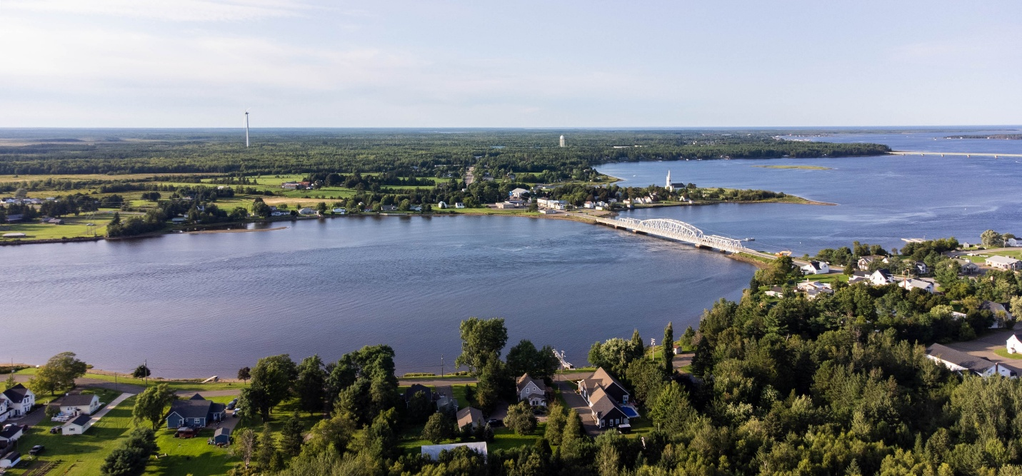

Overview
A Rural Plan is a land use by-law that regulates development by establishing zoning standards and permitted uses within each zone. The Municipality of Five Rivers seeks four residents of Five Rivers to join the municipal committee that will create the first Rural Plan for Five Rivers.
In selecting four residents, the Municipality seeks individuals with personal and/or professional backgrounds that will provide a diversity of perspective and experience. The Mayor and Deputy Mayor of Five Rivers, the CAO of Five Rivers, and a Senior Planner from the Kent Regional Service Commission (KRSC) will also be part of this committee.
At present, Five Rivers, which was created by municipal reform in New Brunswick on Jan 1, 2023, does not have its own Rural Plan. The former village of Rexton has a Rural Plan that was created in 2012. The former Local Service District (LSD) of Harcourt also has a Rural Plan. The former LSDs of Richibucto Parish and Weldford do not have Rural Plans. The Rural Plan that will be created for Five Rivers will apply to the former village of Rexton as well as the LSDs of Harcourt, Richibucto Parish, and Weldford.

About the Committee
Members of the Rural Plan Committee will be expected to attend 4 to 5 meetings from Q3 2025 to Q1 2026. Each meeting can be expected to last 3 to 4 hours. Most will be scheduled for weekday evenings and may also include weekends. Members will be expected to attend all meetings in person at the Municipal Office in Five Rivers (82 Main Street) or the KRSC in Beaurivage (25 Cartier Boulevard, Richibucto). Meetings will have agendas and conclude with minutes that are posted to the municipal website for the public. Members will be expected to read and do research to prepare for meetings and will be required to vote on motions to approve parts of the Rural Plan. Committee members may be compensated for travel expenses and meals may be provided at certain meetings. Committee members will not receive a stipend or any other form of compensation.

Qualifications
- Applicants must be a resident of Five Rivers and 18 years of age.
- Applicants must complete the attached survey to demonstrate how their experience and expertise will help Five Rivers create a Rural Plan. Applicants may also attach their resume.
- Applications must be submitted by Friday, May 16, 2025, by 12:00 PM (noon).
- Applications must be handed to a Five Rivers employee at the front desk of the Municipal Office (82 Main Street, Rexton) in a sealed envelope. Each application will be date- and time-stamped upon receipt.

Applicant Identification
ITEM | RESPONSE
Name
Address
Mobile Number
Occupation
Education

Applicant Survey
Please limit your response to 250 words or less per question.
QUESTIONS
- Why do you want to be part of the Rural Plan Committee for Five Rivers?
- What skills and/or experience do you have that would be valuable to the Committee’s work?
- Are there specific areas or aspects of the Committee's work that you are particularly interested in?
- Have you ever been part of a public committee, or have you been in senior leadership or on the board of directors of a public or private organization? If yes, please identify the organization and describe your role.

Selection Process
All applications will be reviewed by a Selection Committee consisting of Council Members of Five Rivers and the CAO of Five Rivers.
Applicants will be contacted, and committee appointments will be announced, by the Chair of the Selection Committee on or before Monday, June 30, 2025.

