Five Rivers
MUNICIPAL REPORT
2026 Operating Budget Summary
November 2025 | Version 1.00


-- This page intentionally left blank. --

CONTENTS
Basics about operating budgets 4
About the utility operating budget 5
About the general operating budget 5
2026 tax assessment base 6
Comparisons to other municipalities 7
Our property tax rates 7
Our general operating expenditures 8
Our wastewater fees 8
Other notes 9
Key factors for decision-making 11
Key factors for 2026 general operating budget 11
Key factors for 2026 utility operating budget 12
Other notes 12
2026 property tax rates and sewer user fees 13
Property tax rates 13
Multiplier on commercial and industrial properties 13
Sewer user fees 13
Budget summaries 14
General operating budget 14
Utility operating budget 17

Basics about operating budgets
Each year, New Brunswick municipalities must submit two operating budgets to the province: the utilities operating budget for wastewater and the general operating budget for everything else (council, administration, transportation, protective, waste collection, recreation and culture, and more).
Here are some key facts about operating budgets:
- Revenues and expenditures for each budget must be kept separate; municipalities cannot transfer revenues or expenditures between the general operating budget and the utility operating budget.
- Operating budgets are based on the calendar year (Jan 1 to Dec 31) and must be submitted to the province each November.
- Council must approve both operating budgets.
- When each operating budget is submitted to the province, total revenue minus total expenditures must equal $0. A municipality cannot enter a budget or a surplus in an operating budget.
- If revenues exceed expenditures at year-end, the municipality records a surplus for that year. If expenditures exceed revenues at year-end, the municipality records a deficit.
- Municipalities carry surpluses and deficits forward two years (for example, from 2025 to 2027).
- Carried surpluses become revenue in the operating budget; carried deficits become expenditures.
- Most expenditures are non-discretionary; many are set by contracts that are negotiated by the province or the Kent Regional Service Commission on our behalf. For example, the amount we pay for policing service is determined by a provincial contract with the RCMP.
- Municipalities can (and should) transfer a percentage of their operating revenue into one or more capital funds to support future investments in infrastructure (roads, vehicles, buildings, and so on).
The table below shows the main types of expenditures in the general operating budget and the utility operating budget.
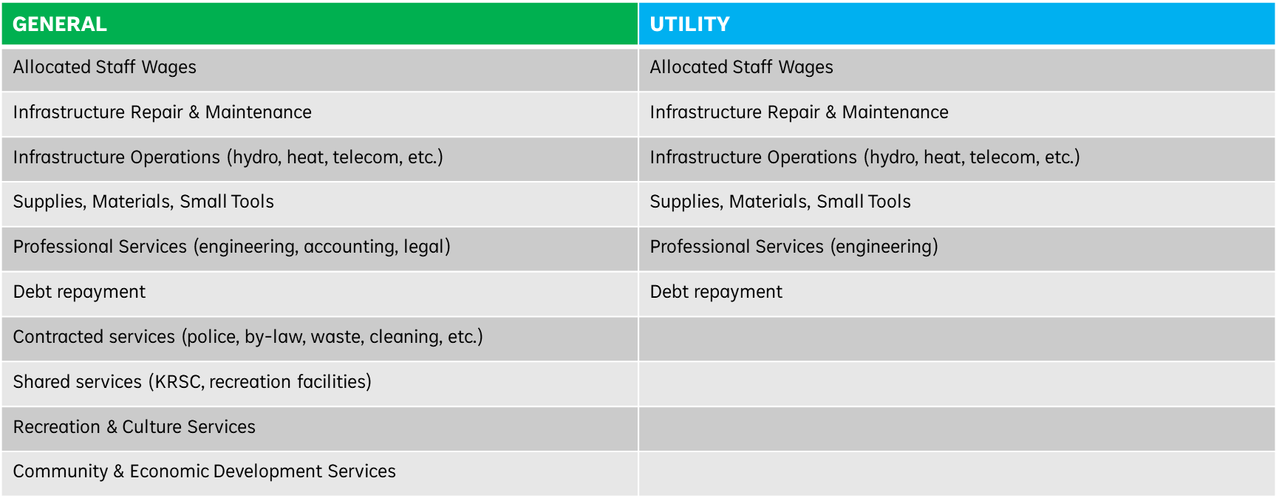

About the utility operating budget
For 2026, the total budget for the utility operating budget will be approximately $350k, up from $309k in 2025. Here are some key facts about the utility operating budget:
- The only residents that pay wastewater fees are those that receive wastewater service from Five Rivers (that is, residents the reside in the former village of Rexton).
- Five Rivers issues about 350 bills for wastewater each year (that is, we have about 350 users). With new construction, we expect the number of bills to increase slightly in 2026.
- Most utility operating revenue (over 90%) is derived from fees for wastewater service as set by the municipality.
- A minority of utility operating revenue is derived from own source fees and fund transfers, for example, from one-time service connection fees.

About the general operating budget
For 2026, the total general operating budget will be approximately $5.3M, up from $4.8M in 2025. Here are some key facts about the general operating budget in Five Rivers:
- Total revenue minus total expenditures must equal $0.
- Most general operating revenue is derived from property tax revenue according to the property tax rates set by the municipality for each taxation area and the property assessments done by the province.
- A minority of general operating revenue is derived from own source revenues and fund transfers, for example, from building permits and recreation fees.
- We have four taxation areas: Rexton, Richibucto Parish, Weldford, and Harcourt.
- Prior to municipal reform in 2023, the province set the tax rates for the former Local Service Districts (LSDs).
- Tax rates for residential properties are set by the municipality and applied to every $100 of assessed value. For example, if the residential tax rate is $1.50, the property tax due for a residential property assessed at $200,000 would be as follows:
($200,000/100) * 1.5 = $3000.
- A multiplier between 1.4 and 1.8 is set by the municipality for commercial and industrial properties. The tax rate for a commercial or industrial property is the residential rate times the multiplier. For example, if the residential property tax rate is $1.50 and the multiplier is 1.50, the property tax due for a commercial property assessed at $500,000 would be as follows:
($500,000/100) * 1.5 * 1.5 = $11,250
- Transportation costs to maintain streets, curbs, and sidewalks in Rexton are not shared with residents in former Local Service Districts (LSDs). This explains, in part, why the property tax rate in Rexton is higher than rates in the former LSDs (even after you add the $0.4115 charge levied by the province for roadwork in former LSDs).

2026 tax assessment base
The table below shows the change in the Tax Assessment Base for Five Rivers from 2025 to 2026.
Note that in 2025, the province decided to freeze tax assessments for 2026. That is, for existing properties that did not do major upgrades (for example, add a garage), tax assessments would be the same in 2026 as they were in 2025.
This means that the increases you see in the table below are attributable to new construction or upgrades.
Five Rivers estimates that it forfeited $200k to $250k in revenue because of the tax assessment freeze.
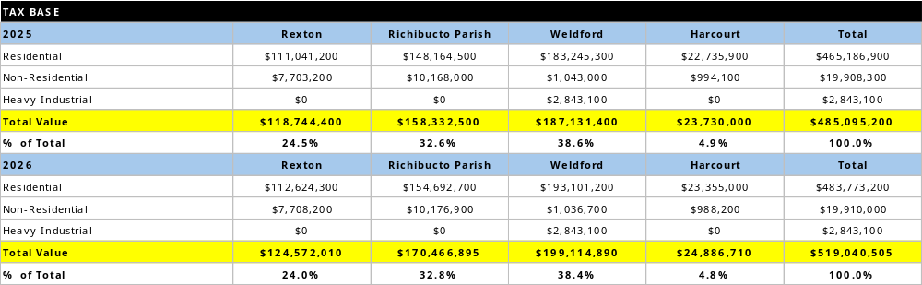

Comparisons to other municipalities
This section provides data from other municipalities that relates to operating budgets.

Our property tax rates
The table below shows property tax rates for 2025 from five similar municipalities.
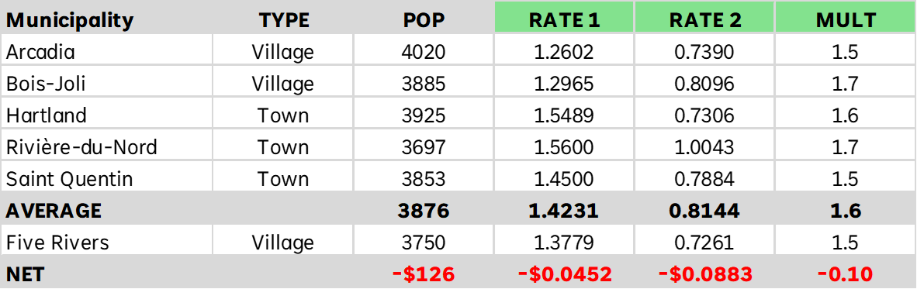
The “Rate 1” column shows the average rate for villages and/or towns in that municipality. Rate 1 in Five Rivers was 4.5 cents lower than the average for the other municipalities.
The “Rate 2” column shows the average rate for former LSDs in that municipality. Rate 2 was almost 9 cents lower than the average for the other municipalities.
Note that our relatively low tax rates compared to other municipalities in our group reduced our eligibility to receive Fiscal Capacity funding (formerly called the Core Funding and Equalization Grant) from the province.
The “MULT” column shows the multiplier applied to commercial and industrial properties.

Our general operating expenditures
The tables below show how Five Rivers compared to similar municipalities in terms of relative expenditure by category for 2025 (the figures in the first table are in 000’s).
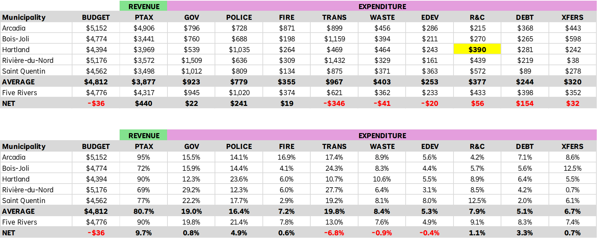
These figures show that Five Rivers spends less on transportation than the reference municipalities, and more on police, fire, recreation, and debt.

Our wastewater fees
To compare wastewater rates, we looked at five other villages and towns in New Brunswick that had wastewater service but not water service: Arcadia, Cap-Acadie, Hautes-Terres, Salisbury, and Three Rivers. The table below compares the 2025 wastewater user fees for these municipalities to the fee in Five Rivers.
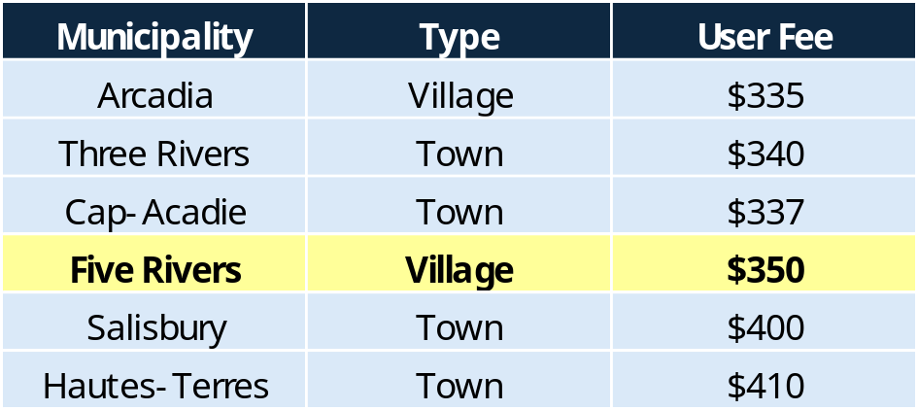
Looking across the province, the table below shows wastewater rates for other municipalities (to be clear, the wastewater rate excluding the water rate).
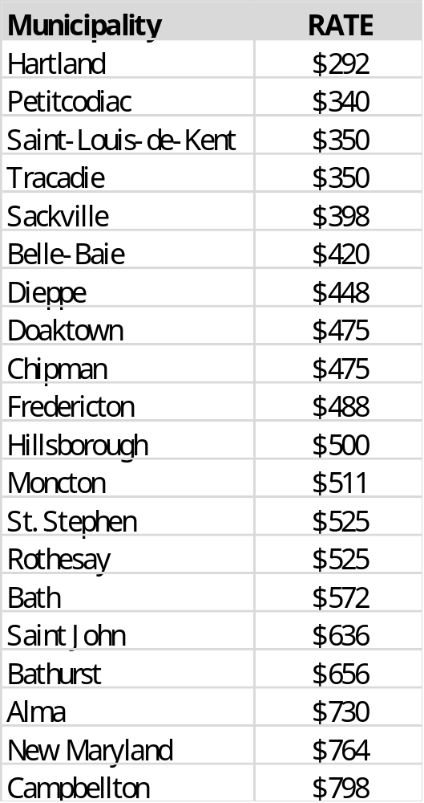

Summary
Relative to similar municipalities:
- Five Rivers has tax rates that are average or below average for municipalities in New Brunswick.
- Five Rivers has sewer user fees that are average or below average for municipalities in New Brunswick.
- Five Rivers has low capital funds (including capital reserve funds) to support future investment in capital assets and infrastructure.

Key factors for decision-making
This section lists and describes the key factors that influenced Council with respect to its 2026 operating budgets.

Key factors for 2026 general operating budget
The Tax Assessment Freeze. In 2025, the province froze tax assessments for 2026. That is, for existing properties, tax assessments would be the same in 2026 as they were in 2025. This significantly reduced the amount of revenue that Five Rivers would receive in 2026. Five Rivers estimates that it forfeited $200k to $250k in revenue because of the tax assessment freeze.
Tax Rate Fairness. In 2025, there was a 17-cent difference between the property tax rate in Harcourt (0.8057) and Richibucto Parish (0.6347), even though residents in Harcourt live further away from Rexton and even though residents in Richibucto Parish receive the same municipal services as residents in Harcourt. For 2026, property tax rates have been adjusted to reduce this differential to 10 cents: Harcourt will be 0.8025 and Richibucto Parish will be 0.7025. In addition, the rate for Weldford was raised from 0.7379 to 0.7755. The property tax rate in Rexton was also increased from 1.3779 to 1.3985. These changes represent the first rate increases in Five Rivers since municipal reform in 2023.
General Economic Conditions. Like a household or a business, municipalities pay for a wide variety of products and services that are sourced from the public and private sector. In 2025, Five Rivers paid higher prices for these products and services, for example, for gas, heat, lights, and many services (legal, accounting, engineering, transportation, etc.). In 2026, we assumed that prices would continue to increase for the products and services we use.
Regional Services. Five Rivers receives several services through the Kent Regional Service Commission, under mandates set by the province, including waste collection services. In 2026, the cost of these services will rise more than 10%, from $627k in 2025 to $693k. Waste collection in particular will increase from $361k in 2025 to $375k in 2026.
Fire and Police Protection. Based on requirements for equipment and operations, the budgets for the Rexton Fire Department and the Beersville/Harcourt Fire Department have increased from $375k in 2025 to $453k in 2026. In addition, special funding was allocated to purchase washing equipment for the Rexton Fire Department and to do roof and parking lot repairs for the Beersville Fire Department. With respect to policing service from the RCMP, for 2026 Five Rivers will pay $1.02M, up $20,000 from 2025.
Transportation. Five Rivers plans to spend more to repair & maintain transportation infrastructure (streets, roads, curbs, sidewalks) in Rexton in 2026. The budget for 2026 is $517k, up from $461k in 2025. In addition, Five Rivers had to allocate $59k to pay its share of the cost to upgrade Main Street under the Provincial Municipal Highway Partnership (PMHP) program.
Works Vehicles & Equipment. The public works department has aging and failure-prone assets (vehicles, heavy machinery, and equipment, for example, snow clearing machines) and a limited set of small tools and equipment. To improve this situation over time, more funds were allocated in the operating budget.
Staffing. To enhance service quality and service levels, and to better align wages and benefits with like municipalities, Five Rivers will increase funding for staffing by approximately $85k in 2026.
Debt Repayment and Reserve Transfers. In 2026, Five Rivers will pay approximately $45k in interest and principal for a new, $350k debenture that was borrowed for a new fire truck for the Rexton Fire Department. To support future investment in capital assets, Five Rivers plans to transfer approximately $164k to capital reserves (about 3% of the overall general operating budget).

Key factors for 2026 utility operating budget
Aging Infrastructure. Like many other municipalities, Five Rivers has aging wastewater infrastructure that is at risk of failure. In 2025, we paid more than $20k to repair broken sewer pipes on Main Street and $40k to repair our main lagoon inlet. In addition, based on the results of a provincial audit and in consultation with our wastewater engineers, our lagoon will need further repair and maintenance to meet requirements for capacity and quality. This work will strain available funds and explains why the rate increase was implemented.
General Economic Conditions. Like a household or a business, municipalities pay for a wide variety of products and services that are sourced from the public and private sector. In 2025, Five Rivers paid higher prices for these products and services, for example, for gas, heat, lights, and many services (legal, accounting, engineering, transportation, etc.). In 2026, we assumed that prices would continue to increase for the products and services we use.
Past Deficits & Surpluses. In 2025, Five Rivers will have almost $30,000 less revenue due to a reduction in its 2024 year-end balance compared to 2023. In addition, in 2026 Five Rivers will pay nearly $19k for a deficit from a prior year that it is paying back over 5 years (as is allowed under provincial rules).
Debt Repayment and Reserve Transfers. In 2025, Five Rivers completed a 3-year, $3.1M project to upgrade sewer system infrastructure. In 2026, Five Rivers will pay nearly $78k to service the debt related to this project. With respect to our utility capital funds, including reserves, Five Rivers will end 2025 with exceptionally low capital funds, in large part because we emptied them to pay our share of the $3.1M project (the part funded by us rather than the province or federal government). This left Five Rivers with no significant capital funds to pay for future infrastructure projects, including work that must be done to fix and upgrade the wastewater system. For this reason, nearly $80k was allocated to go into capital reserves in 2026.

Other notes
In 2026, the following will be true:
- Nearly 30% of the Five Rivers general operating budget will go to protective services, which includes policing, fire protection, by-law enforcement, emergency management, and animal control services.
- Five Rivers will spend about 10% of its general operating budget on recreation and culture.
- In keeping with its remuneration by-law, members of Council will receive a 2.2% increase in their honorarium, based on the Consumer Price Index for New Brunswick.

2026 property tax rates and sewer user fees

Property tax rates
The table below shows property tax changes from 2025 to 2026 in Five Rivers.
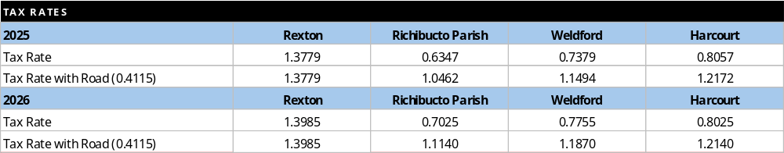

Multiplier on commercial and industrial properties
Note that the multiplier for commercial and industrial properties will increase from 1.50 to 1.55.

Sewer user fees
The base sewer fee in Five Rivers will increase from $343 for 2025 to $465 in 2026.

Budget summaries
This section shows how funds are being spent in the general operating budget and the utility operating budget.

General operating budget

General operating budget revenue
Nearly 90% of total general operating revenue is derived from property taxes. Five Rivers receives very little funding from the provincial CFEG (Core Funding and Equalization Grant) program and much less than other municipalities of a similar profile (population, tax base, etc.). In 2026, Five Rivers will carry a $274,000 surplus from 2024 as revenue.
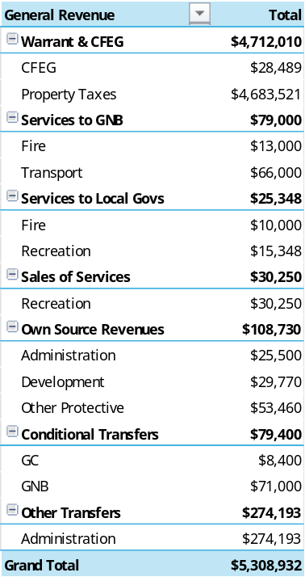

General operating budget expenditures
For 2026, nearly 30% of the budget will go to police (RCMP) and fire services, not including debt repayment on prior leases and debentures for fire department assets. Relative spending on recreation (10.4%), solid waste (7.1%), and transportation (12.6%) increases nominally in 2026 over 2025.
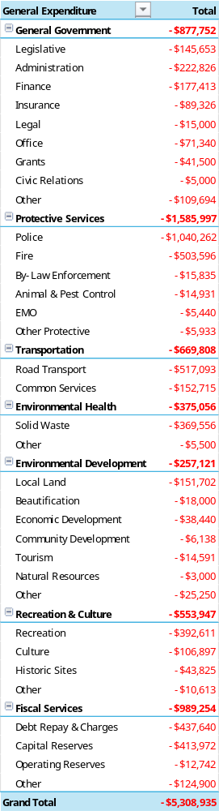 | 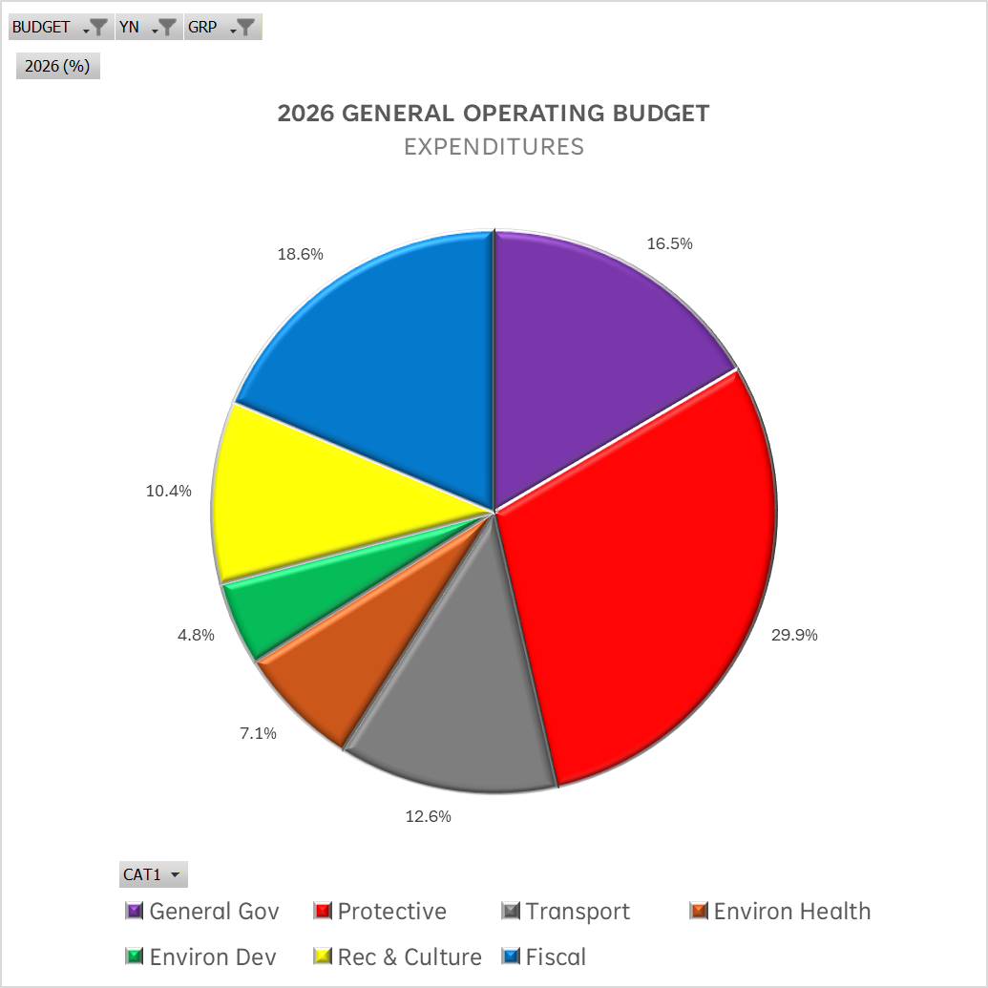

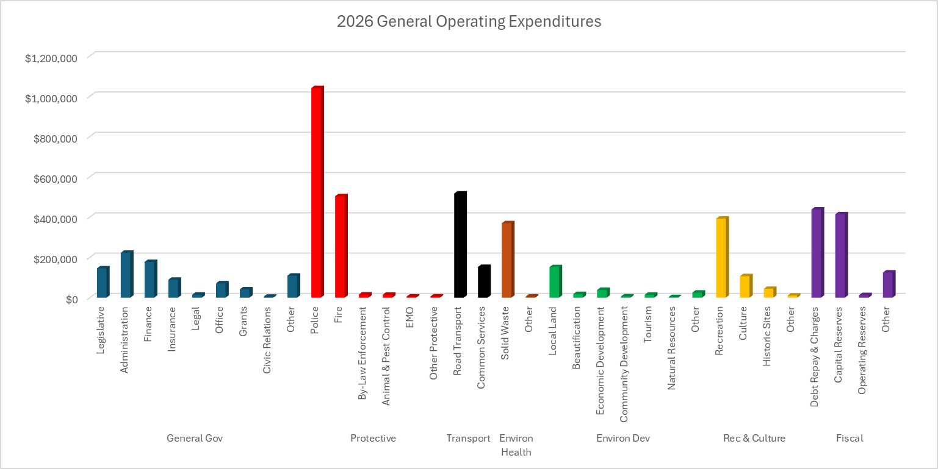

Utility operating budget

Utility operating budget revenue
94% of utility operating revenue comes from user fees.
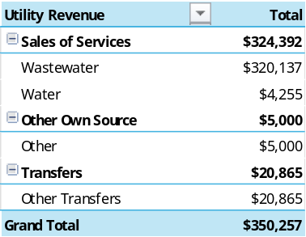
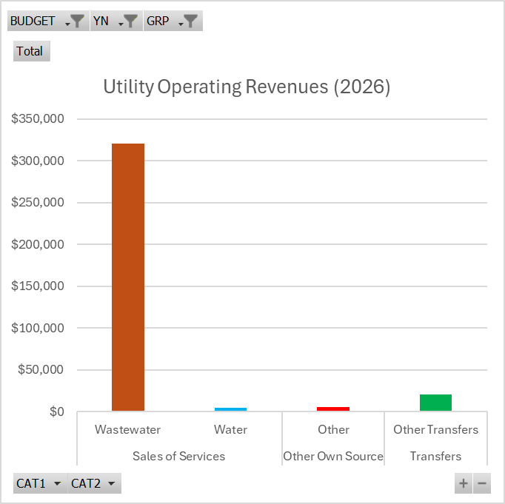

Utility operating budget expenditures
Nearly 60% of utility operating expenditures relate to operation of the wastewater system, including labor. 41% of utility operating expenditures relate to fiscal services, including debt repayment (largely related to the new 20-year debenture for $750,000 borrowed to pay for the now completed $3.1M wastewater project) and transfers to reserves (because reserves were depleted by the wastewater project in 2025).
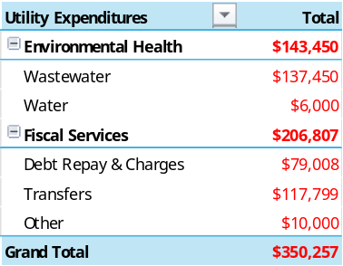
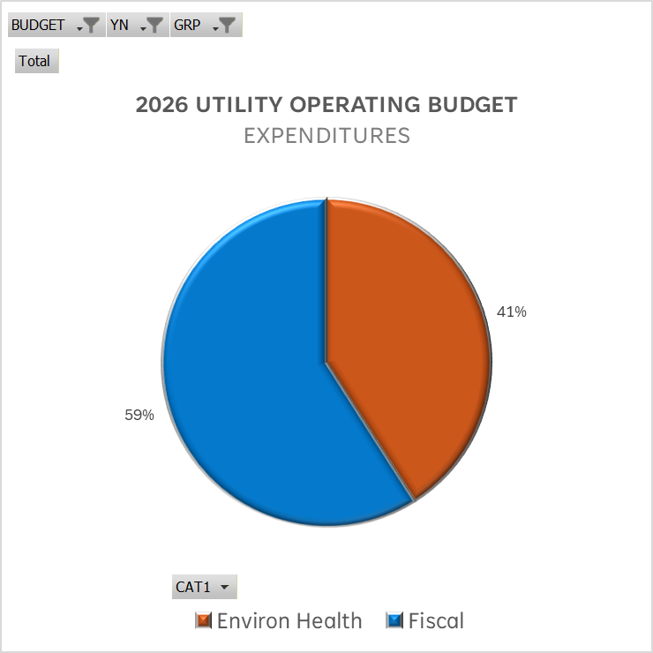
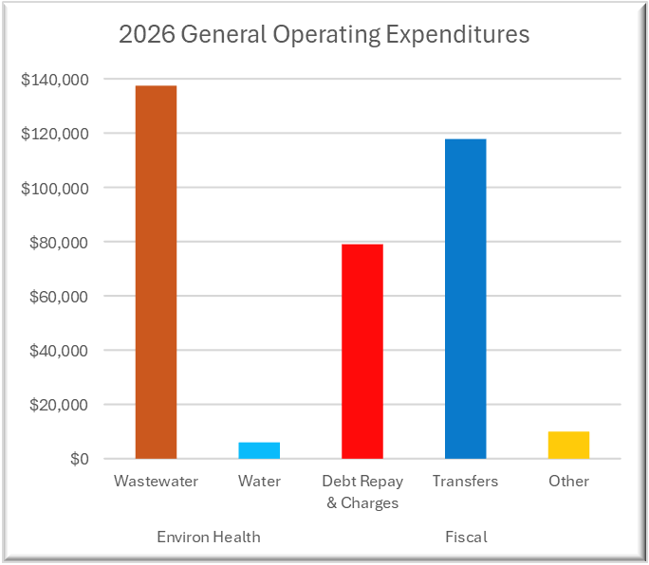

Arcadia and Bois-Joli are villages with populations of 4020 and 3885, respectively. Hartland, Riviere-du-Nord, and Saint Quentin are towns with populations of 3925, 3697, and 3853, respectively.

